1. 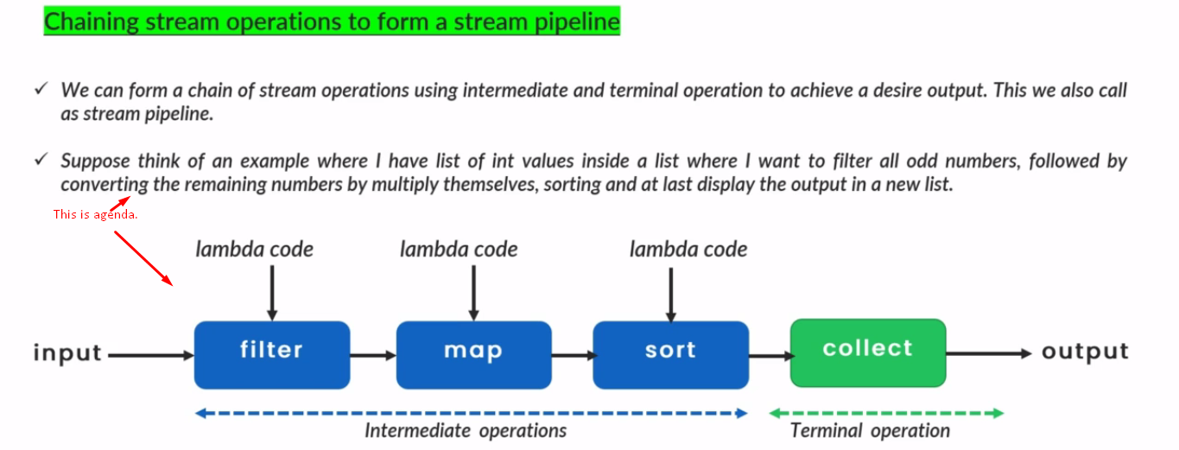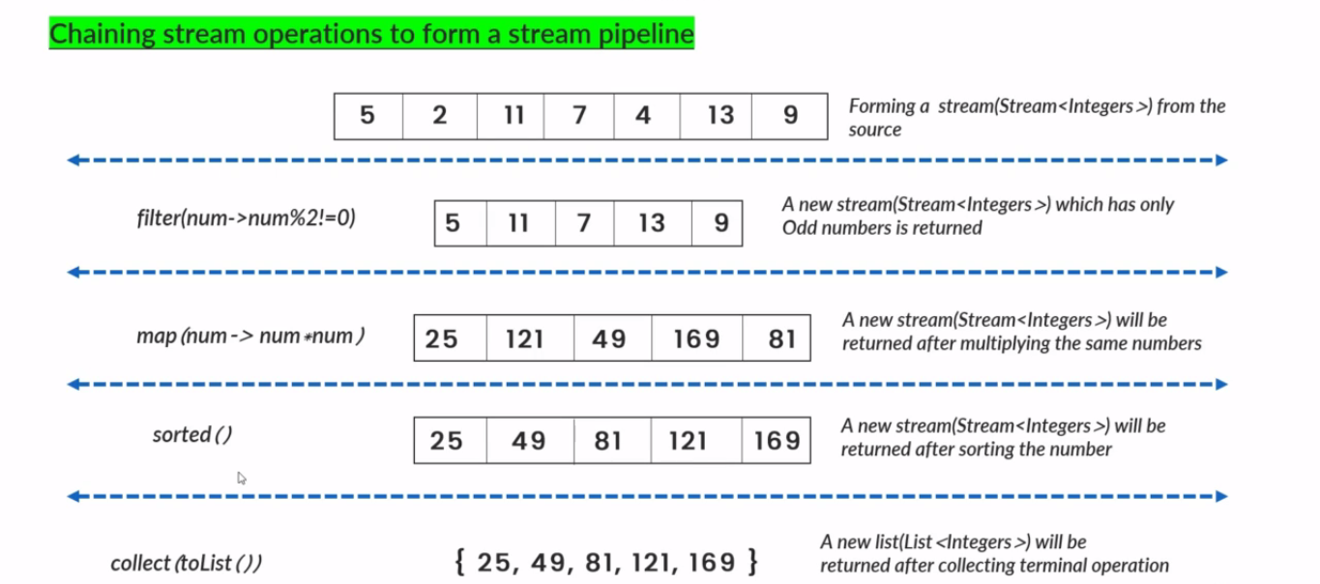
2. So, you can see with help of lambdas and stream pipeline, we can write any complex business logic.
3. 